# CLOUD APPLICATION DEVELOPMENT

**DISASTER RECOVERY WITH IBM CLOUD VIRTUAL SERVERS**

Disaster recovery (DR) is a systematic process designed to help organizations respond to and recover from disruptive events that could severely impact their operations. These disruptive events, often referred to as "disasters," can come in various forms, including natural disasters (e.g., earthquakes, hurricanes), human- made disasters (e.g., cyberattacks, data breaches), hardware failures, or other unexpected events that can disrupt business operations.

The primary goal of disaster recovery is to minimize downtime and data loss, ensuring that an organization can continue functioning even in the face of such disasters. Here are some key components of a disaster recovery plan:

1. **Business Impact Analysis (BIA):**This is the initial step in disaster recovery planning. It involves identifying critical systems, applications, and data, as well as determining the impact of their unavailability on the organization's operations.
2. **Risk Assessment:** Assess and identify potential threats and vulnerabilities that could lead to disasters. This includes environmental factors, technological risks, and human factors (e.g., user errors, malicious activities).
3. **Recovery Time Objectives (RTO) and Recovery Point Objectives (RPO):** Define the acceptable downtime and data loss for each system or application. RTO represents the maximum tolerable downtime, while RPO represents the maximum allowable data loss.
4. **Backup and Data Replication:** Regularly back up critical data and replicate it to a secure offsite location. Data replication ensures that data remains available in a different location in real-time or near-real-time.
5. **Redundancy and High Availability:** Implement redundancy in systems and infrastructure to ensure continuous availability. This might involve clustering, load balancing, or maintaining duplicate systems in geographically diverse locations.
6. **Disaster Recovery Procedures:** Develop detailed recovery procedures for each critical system or application. These procedures should outline the steps to be taken in the event of a disaster, including data recovery, system restoration, and failover.
7. **Communication Plan:** Establish a communication plan to ensure that all stakeholders are informed in the event of a disaster. Define roles and responsibilities for communication and decision-making.
8. **Regular Testing:** Conduct regular disaster recovery drills and exercises to ensure that the plan is effective. This includes simulating disaster scenarios and practicing recovery procedures.
9. **Documentation:** Maintain comprehensive documentation of the disaster recovery plan, including configurations, contact information, and procedures.
10. **Monitoring and Alerting:** Implement monitoring tools to detect issues and potential disasters. Configure alerts to notify relevant personnel in real-time.
11. **Compliance and Legal Considerations:** Ensure that the disaster recovery plan complies with legal and regulatory requirements specific to your industry and region.
12. **Periodic Review and Updates:** Regularly review and update the disaster recovery plan to adapt to changes in your infrastructure, technology, and business needs.

# REPLICATING DATA AND VIRTUAL MACHINE (VM) IMAGES:

Replicating data and virtual machine (VM) images from on-premises to IBM Cloud Virtual Servers involves several steps.

## Prerequisites:

1. **IBM Cloud Account:** Ensure that you have an IBM Cloud account and access to IBM Cloud Virtual Servers.
2. **On-Premises Infrastructure:** You need to have your on-premises infrastructure ready, which includes the VMs you want to replicate.
3. **Network Connectivity:** Establish a secure and reliable network connection between your on-premises data center and IBM Cloud. This can be done using a VPN, Direct Link, or a similar method.

## Step 1: Prepare On-Premises Environment

1. **Inventory Assessment:** Create an inventory of VMs and data that need to be replicated. Ensure that the VMs are up to date and have necessary backups.
2. **Network Configuration:** Set up a VPN or Direct Link connection between your on-premises environment and the IBM Cloud network.

## Step 2: Replicating Data

There are several options for replicating data, and the choice depends on your specific needs and environment. Here's a common approach:

1. **Backup and Recovery Tool:** Use a backup and recovery tool like IBM Spectrum Protect to create backups of your on-premises data. Ensure that these backups are stored securely and are ready for transfer.
2. **Data Transfer:** Use secure methods (e.g., SCP, SFTP, Rsync, or dedicated backup tools) to transfer the backup data to your IBM Cloud environment. You can use a secure channel over your VPN or Direct Link.
3. **Data Storage in IBM Cloud:** Store the transferred data in IBM Cloud Object Storage, which is highly scalable and suitable for backup data.

## Step 3: Replicating Virtual Machine Images

To replicate VM images, you can use tools such as IBM Cloud Continuous Data Replicator or other methods depending on your specific use case. Here's a general approach:

1. **Image Export:** On your on-premises environment, export the virtual machine images you want to replicate. This can be done using built-in tools (e.g., VMware's vSphere) or third-party solutions.
2. **Data Transfer:** Similar to data transfer, securely transfer the virtual machine images to IBM Cloud using the VPN or Direct Link connection.
3. **Image Import:** In your IBM Cloud Virtual Servers, create new VM instances or use an existing image repository to import the replicated VM images. Make sure to configure the VMs according to your needs.
4. **Configuration Migration:** Update the configuration settings of the VMs in IBM Cloud to match your on-premises environment. This includes network settings, storage, and any other specific configurations.

## Step 4: Testing and Validation

After replicating the data and VM images, thoroughly test the VMs in the IBM Cloud environment to ensure that they function correctly. This involves verifying data integrity and the functionality of the applications running on the VMs.

## Step 5: Ongoing Replication and Monitoring

Set up a process for continuous data and image replication to keep your IBM Cloud VMs up-to-date. This may involve scheduling regular backups and transfers.

# DISASTER RECOVERY PLAN:

Creating a disaster recovery plan (DRP) that includes configuring replication and testing recovery procedures is crucial for ensuring the continuity of your IT infrastructure in case of unexpected incidents. Here's a step-by-step guide on how to do this:

## Define Your Disaster Recovery Objectives:

* + Identify critical systems and data: Determine what systems, applications, and data are vital for your business operations.
  + Establish recovery time objectives (RTO) and recovery point objectives (RPO): Define the maximum allowable downtime and data loss for each system or application.

## Select a Replication Strategy:

* + Decide on the replication method: Choose between synchronous or asynchronous replication depending on your RTO and RPO requirements.
  + Choose a replication tool or service: Select a solution that fits your environment, such as IBM Cloud Continuous Data Replicator or other replication technologies.

## Set Up Replication:

* + Configure replication for critical systems and data from your primary on- premises location to a secondary location, which can be an IBM Cloud environment.
  + Ensure network connectivity: Establish a reliable and secure network connection between your primary and secondary sites.

## Data Backup:

* + Implement regular backups of your data, both on-premises and in the secondary location, to ensure data integrity.

## Document Recovery Procedures:

* + Create a comprehensive recovery plan that outlines the step-by-step procedures for recovering each system and application. Include contact information for key personnel and third-party vendors.
  + Document dependencies between systems and applications.

## Train Your Team:

* + Ensure that your IT team is well-trained on the DRP and the procedures involved in recovery.

## Perform Regular Testing:

* + Schedule regular DRP testing and recovery drills. This can include tabletop exercises and full-scale simulations.
  + Test different disaster scenarios, such as data corruption, hardware failures, and natural disasters.

## Evaluate and Update the DRP:

* + After each testing phase, review the results and make necessary adjustments to the DRP based on lessons learned.

## Monitor and Maintain:

* + Implement continuous monitoring of your replication and recovery systems to detect and address issues promptly.
  + Update your DRP as your infrastructure changes over time.

## External Considerations:

* + Consult with regulatory authorities or industry standards to ensure compliance with data protection requirements.
  + Consider third-party disaster recovery providers for additional redundancy and expertise.

## Communication Plan:

* + Develop a communication plan to keep stakeholders informed during a disaster. Define roles and responsibilities for communication.

## Vendor Support:

* + Ensure that your replication and disaster recovery tools have adequate vendor support and consider managed services for more complex environments.

## Document Everything:

* + Keep detailed records of configurations, settings, and test results for future reference.

## Legal and Compliance Considerations:

* + Ensure that your DRP complies with any legal or compliance requirements specific to your industry or region.

## Review and Update Your DRP Regularly:

* + Regularly review and update your DRP as your infrastructure, applications, and business needs evolve.

# DISASTER SCENARIO AND PRACTICE RECOVERY PLAN:

Simulating a disaster scenario and practicing recovery procedures is a crucial aspect of disaster recovery planning. In this text-based simulation, we'll simulate a scenario where a critical file gets deleted and then practice the recovery procedure to restore it. Here's how to simulate and practice the recovery of a deleted file:

## Step 1: Set Up Your Environment

1. Create a directory for this simulation. You can name it something like "DisasterRecoverySimulation."
2. Inside the directory, create two subdirectories: "source" and "backup."
3. Place a sample file (e.g., "important_data.txt") in the "source" directory. This file represents your critical data.

## Step 2: Simulate the Disaster

In this step, you'll simulate the disaster by intentionally deleting the critical file.

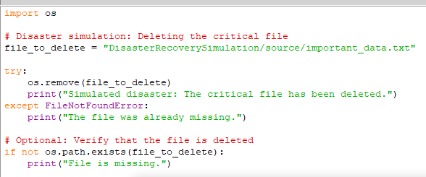

# OUTPUT

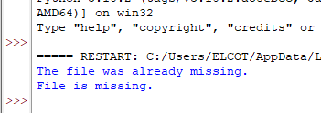

## Step 3: Practice Data Recovery

Now, you'll practice the recovery of the deleted file from the backup directory.

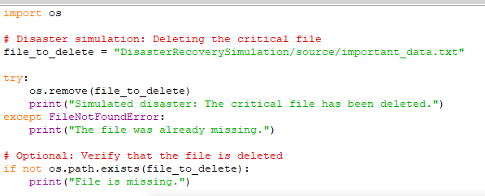

# OUTPUT

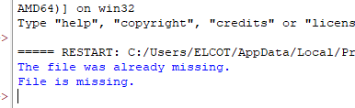

## Step 4: Verify Data Recovery

Check whether the critical file has been successfully restored in the "source" directory.

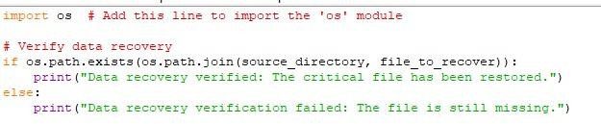

# OUTPUT

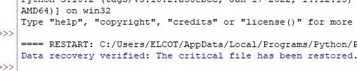

**PROGRAM**

This program simulates data backup and recovery for a hypothetical configuration file, which could represent critical configuration data that you want to back up in a disaster recovery scenario:

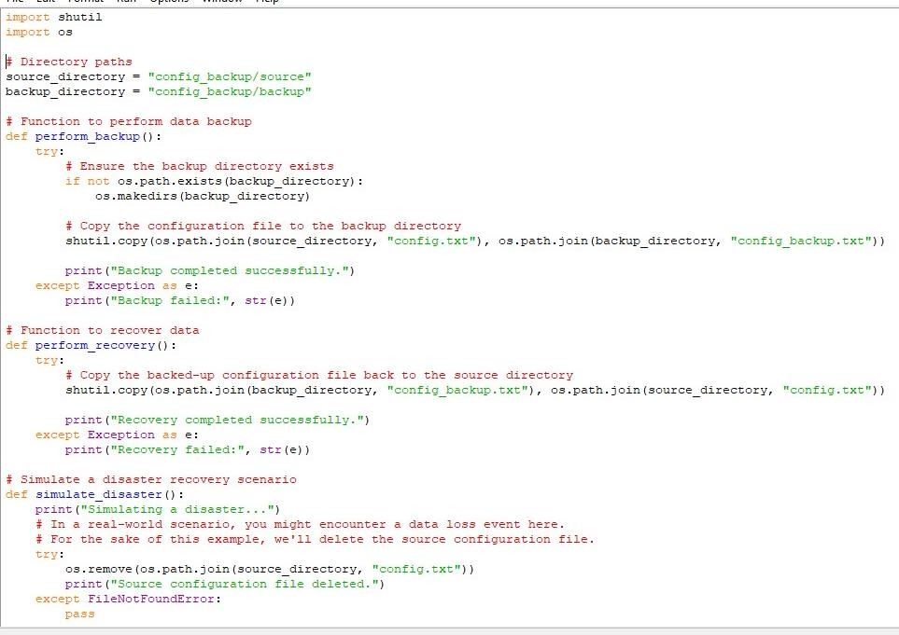

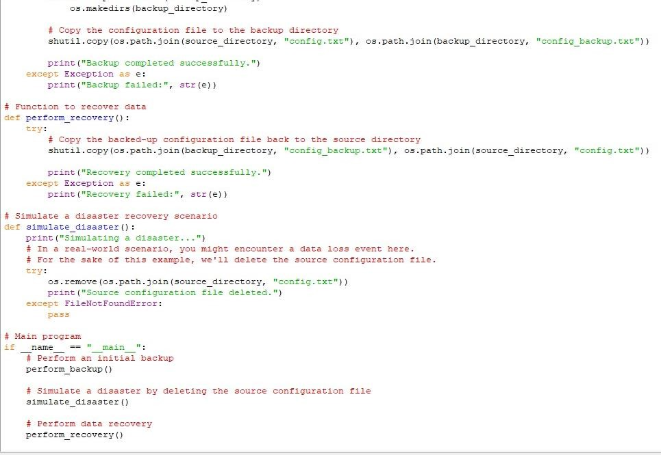

**OUTPUT**

